

Chris North

Christopher StLouis

Mona Parvin

Frank Pinder

Patient Process Interface

Deliverable 3: Software Design Document

22 May 2006

Macrohard Inc

Team Lead
Chris North
Christopher StLouis

Team Members

Name Role
Mona Parvin Author
Chris North Author
Christopher StLouis Author
Frank Pinder Author

Table of Contents:

Introduction 3
1.1. Purpose of this Document 3
1.2. Scope of the Development Project 3
2. Revised Requirements 3
3. Data Design 3
3.1. Sequence Diagram 3
4. Architecture Design 8
4.1. Class Diagram 8
5. Procedural Design 9
6. User Interface Design 10
7. Programming Tools 10
8. Restrictions, Limitations, and Constraints 11
9. Administrative or Support Tasks 11
10. Code Maintenance Tasks 11
11. References 11
12. Appendix 11

Introduction

This is a Software Design Document for the Single Medical Provider Franchise, Patient Process Interface. The Software Engineering company, Macrohard Inc, was chosen to take on this project. This document has been created by three students, earning their Bachelors Degrees, in the College of Engineering and Computer Science at California State University, Sacramento. The team members are enrolled in Software Engineering, an Upper Division Computer Science course.

Purpose of this Document
The Software Design Document (SDD) is a comprehensive software design model, for the Patient Process Interface, consisting of four distinct but interrelated activities: data design, architectural design, interface design, and procedural design. The PPI Client Interface is a stand-alone component of the overall PPI system.

The intended audience of this document is the development team. The development team will be able to read the document and have enough detail to implement the solution.

Scope of the Development Project
The Patient Process Interface is an internet application owned by the client, owner, and distributed to the franchised service providers. The consumer is the application’s client, and is able to register themselves in the application, browse provider services, order and schedule service appointments.

However, the system to be implemented has a limited scope of the overall PPI. The owner, provider, and scheduling components will not be implemented.

Revised Requirements

There were no revised requirements that differed from the SRS. The SRS is the most updated source for all the requirements.

Data Design

Sequence Diagram

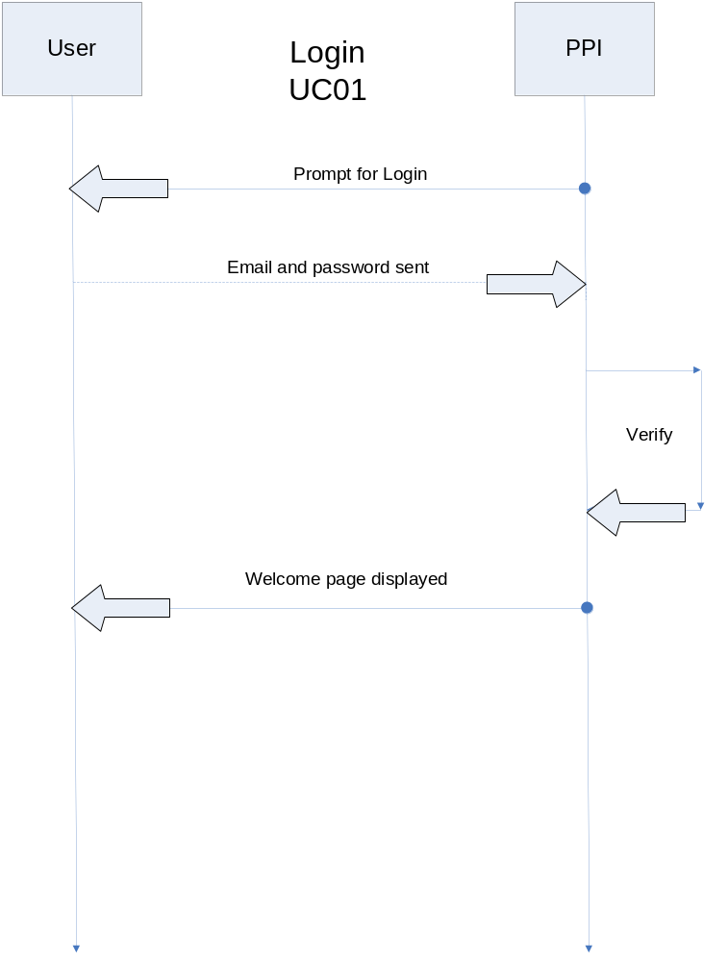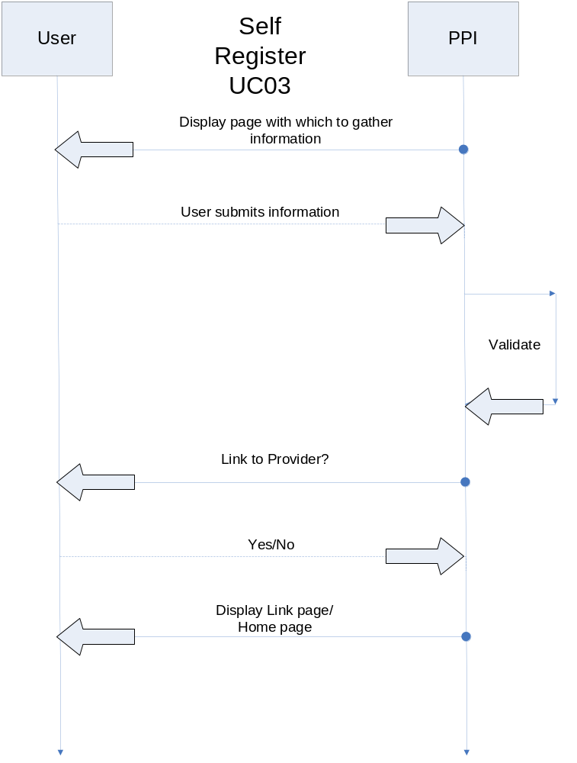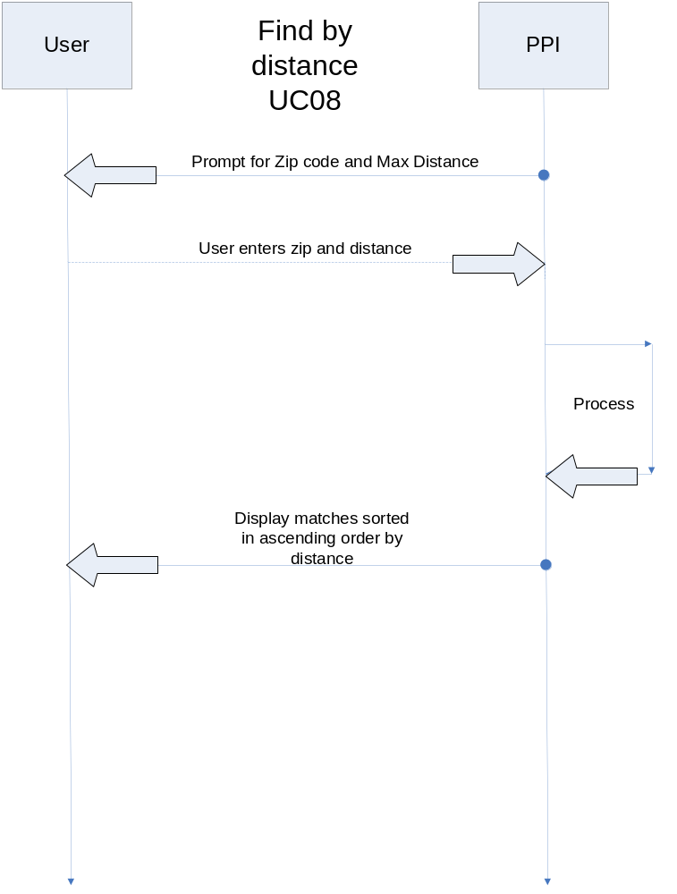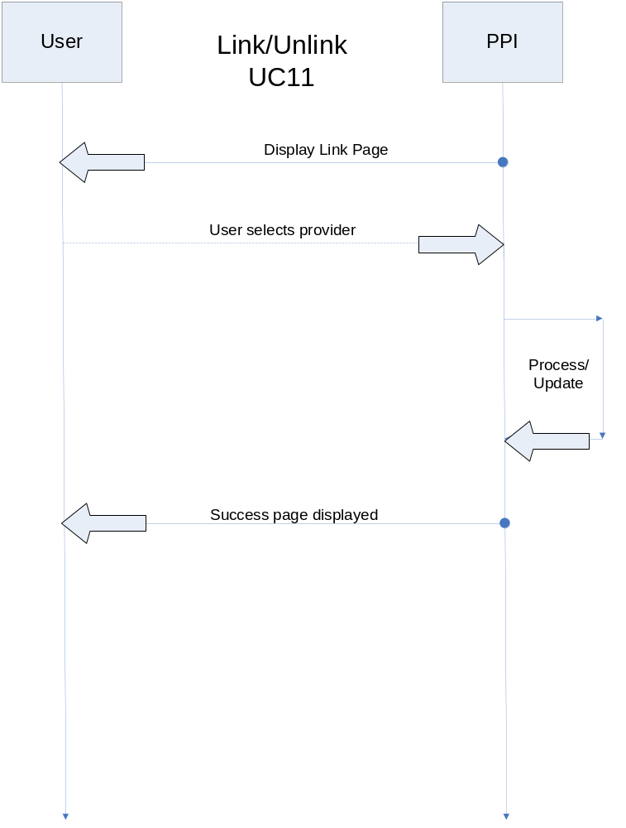

Architecture Design

Class Diagram

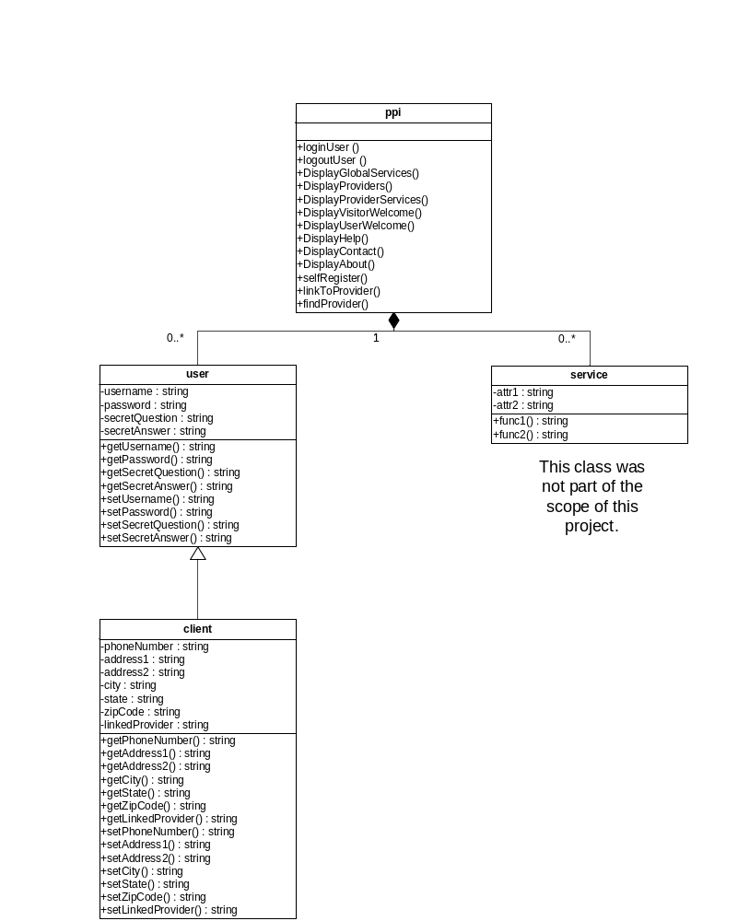

Procedural Design

5.1 PPI Class

5.1.1 selfRegister() : Used to register a new user into the database and give them the opportunity to access the more sensitive areas of the site.

Psuedocode:

get input from user fields that are displayed
test to see that required entries are not empty and valid.
store each data field in the sql database
display welcome page and home page the thereafter

5.1.2 loginUser() : Allow user to login and provide a means of logging in if password is forgotten.

Psuedocode:

read login and password
cross reference login in database:
if exist, check password
else display login not found, try again until a valid email address is found?

If password matches stored value for the login, proceed to homepage.
else let user try twice more (3 times total). Then use alternate login.

Alternate Login:

read email
cross reference with sql database:

if found, display secret question
else display not found message, suggest to user the option to self-register. Go to self register page if accept, otherwise go to index.

read secret answer
if secret answer matches stored answer, allow user to reset their password and display homepage
else let user try 2 more times, if still it does not match display a link to email the system administrator.

5.1.3 findProvider() : Used to find providers by entering a zip code and specifying a search radius. Providers are displayed in ascending order of proximity.

Psuedocode:

prompt for zip and max traveling distance.
Use phpZipLocator
if no locations available within radius, inform user, allow to try again.
else use phpZipLocator’s output and sort by distance in ascending order.

User Interface Design
A screenshot is provided for maximum clarity as to how the user interface is designed.

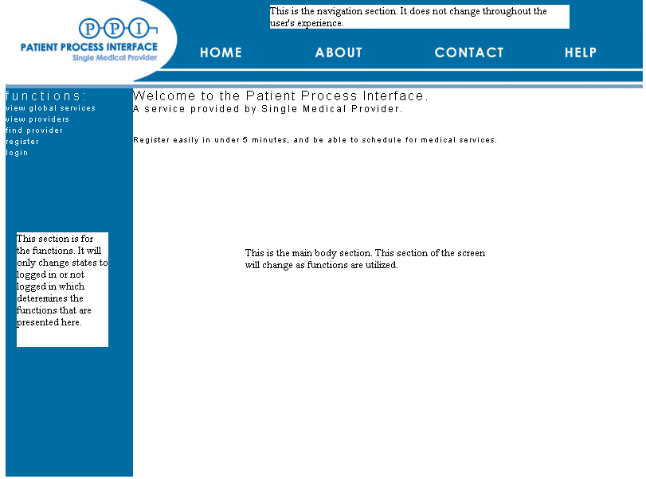

Programming Tools
  - PHP: This is the programming language of choice when dealing with web based applications because it is easily transmitted over the World Wide Web. It is an architecture neutral, object oriented language that can be run on any web server that has the PHP runtime. It is open source.
  - MySQL: This is the DBMS software of choice when developing a database driven web application. It is often used with PHP, and PHP offers a robust API to interact with MySQL. It is open source.
  - OpenSSL: This is the SSL software of choice when developing web applications running on an Apache web server and requiring SSL and HTTPS security. It is open source.
  - Apache: This is the web server software of choice. It enables a server system to run as a web server, and execute web application pages, over a secure SSL connection, containing PHP code. It is open source.
  - XHTML, CSS, JavaScript: These “languages” are fundamental building blocks of today’s most popular web sites and applications. These tools are compatible with all current client-side web browsers.
  - Adobe Dreamweaver and Photoshop: These software packages are, commercially available tools, used for designing and organizing web applications, which are the medium of communication on the web.

Restrictions, Limitations, and Constraints

- This is all done with open-source software as specified.

- Currently users are only able to search by zip code, it is a rough estimate but it was what was required. The zip database needs to be updated whenever new zip codes are added.

Administrative or Support Tasks

- Data object clean-up is beyond the scope of the requirements.

- Users that have lost their passwords will have a chance to answer their secret questions. Only upon failing to remember their secret answer will there be a need for administrative assistance.

- Encryption of data can be applied to any field, just follow the password example with AES_ENCRPYT and any value may be encrypted in the database. This was intentionally left unencrypted for debugging purposes.

Code Maintenance Tasks

- Monitoring the MySQL database for up-to-date provider information will most-likely be the only maintenance that is necessary. Although once the provider-side portion of PPI is finished, the provider may edit their own data.

- There may be times when the status fields of certain users need to be updated. (Ex. Active, Inactive, Deceased, etc.)

References

N/A

Appendix

SRS is provided with this documentation. See SRS for full account of the requirements.

